Amazing Samples: The Low-down on Stool
Posted by Jaydeb Mukherjee on Apr 1, 2015 11:00:00 AM
I have to say, my favorite piece of furniture (after a good mattress) would definitely be the stool.
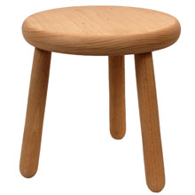
Specifically, my favorite would be the three-legged variety, which traces its roots back to the Dutch in the year 1619, when multiple attempts to take prax--
Wait, what? "Wrong stool"?... Actually, that makes more sense.
As we’ve previously discussed, materials commonly considered as physical waste can often be treasure troves of information. Urine, rich in biomarkers, is usually flushed without a second thought; hair is vacuumed up and thrown away, despite the growing value it’s showing as a research subject.
So it should come as no surprise that there are piles of research regarding the information hidden in feces.
Our previous post in the Amazing Samples blog series took a serious look at miRNA, only recently discovered. This time, let’s pay homage to the time of year, and discuss the scientific value of the butt of so many schoolyard jokes – poop.
Mozart would be proud.
Compost-sition
Everyone is taught as a child that bowel movements are unsanitary, and for no small reason – the bacteria found in it (Escherichia coli) is toxic should it get in the wrong end of the gastrointestinal (GI) tract, and is one of the three bacterial genera responsible for the vast majority of food poisoning outbreaks (accompanied by Salmonella and Listeria). Additionally, most students who take a biology class have worked with E. coli in elementary lab courses, as it’s both hardy and easy to obtain.
Then, obviously, it contains remnants of your diet, which is why stool can be so useful both practically (as fertilizer or “night soil”) and informatically. Analyzing the remaining, undigested nutrients can help indicate a number of GI issues, whether a temporary infection or a chronic disease like Crohn’s disease. Additionally, paleofeces (no relation to fad diets) is an invaluable tool for archeologies, both anthropological and zoological. The ability to analyze the historical diets and GI diseases that ancient humans or extinct animals have had provides great insight, not to mention it’s been indicated to be an even better source of DNA than bones.
Past that, what else is in there? A good bit, it turns out. While the exact composition will vary substantially based on individual and diet, this list gives a quick and dirty overview, showing that even among the food by-products, more than you might expect is bacteria (30% of solid matter), or even inorganic (10% of solid matter).

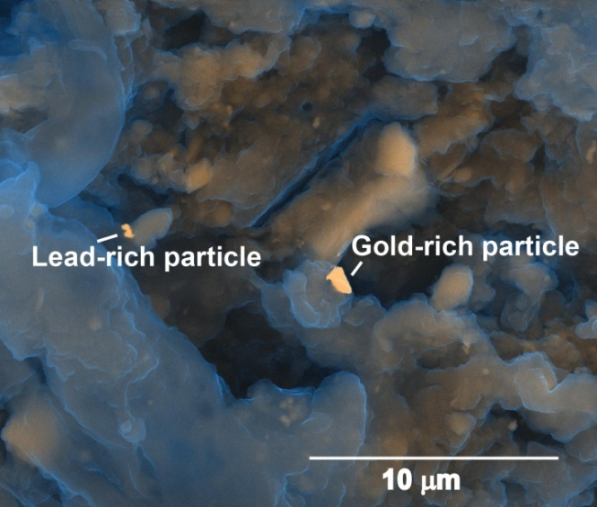
Inorganic? What, like gold?
It’s funny you might say that – yes, actually. According to work presented last Thursday at the 249th National Meeting & Exposition of the American Chemical Society, human feces contains a range of rare elements and metals, including vanadium, palladium, silver, and even gold. Even if we have yet to develop the technologies to isolate these metals cheaply and efficiently, the idea of discarding the $13 million worth of metals produced annually per million-person community this study estimates should be some incentive to innovate such methods.
Additionally, some of these metals are considered biologically toxic (most obviously, lead), and thus restrict the amount of feces that can be used as fertilizer. Therefore, separating the metal from stool would increase the usability and value of both remaining components. That being said, you’ll still need to thoroughly wash any such fertilized produce.
Granted, fecal flora is more useful than you might think, because…

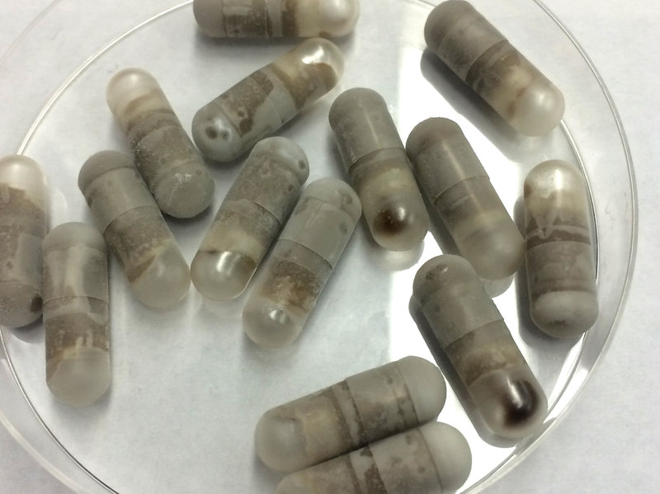
Poop Pills Can Save Lives
A class of infections that has only recently emerged is from Clostridium difficile, an antibiotic-associated illness that was connected to 29,000 US deaths in 2011. This infection is thought to arise when the naturally-occurring intestinal bacteria is compromised by antibiotics, providing the bacteria to opportunistically invade, causing intense diarrhea and pain, even in the non-fatal cases (here is the CDC’s fact sheet for prevention). While stopping the administration of the offending medicine might help, and there are antibiotics that specifically target C. difficile, it has turned out that one of the easiest ways to restore balance to your bowels is with a fecal microbiome transplant (FMT).
That’s exactly what stool banks like OpenBiome are doing. This startup from MIT has developed a biorepository that rigorously screens fecal transplant donors before accepting the material, then processes, stores, and ships it to clinics, providing unprecedented accessibility to patients in need of healthy stool. Watch this video for more information (and a few giggles):
As they mention in the video, they’re also attempting to develop a pill-based method of FMT delivery, and they’re not the only ones.SeresHealth is developing a similar therapeutic not only to fight against C. difficile, but against other antibiotic-resistant bacterial infections as well. It might seem a bit hard to swallow right now, but soon enough, we might have life-saving medicines on the market that are derived from feces!
Just because we’ve been discarding it for thousands of years, we shouldn’t disregard the potential value that stool can have in any number of applications! Poop truly can be an Amazing Sample.
Do you work with stool samples? If so, download our eBook Standardizing Biosample Management: Why Use Collection Kits? to learn cost effective ways to collect samples!

